Hadith #1 Student Worksheet

Title: _________________________________________

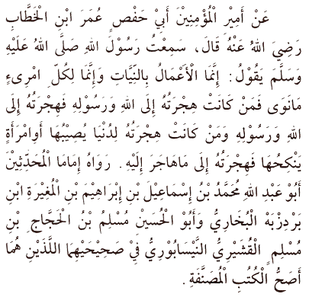

English Translation _______________________________________________________

_______________________________________________________________________

_______________________________________________________________________

_______________________________________________________________________

_______________________________________________________________________

_______________________________________________________________________

Why is this hadith so important and who said it? _______________________________
_______________________________________________________________________
_______________________________________________________________________
_______________________________________________________________________
_______________________________________________________________________
Who was this hadith about? ______________________________________________

Intentions are composed of two parts:
1. _____________________________________________________________________

2. _____________________________________________________________________

Two ayats that support this notion are: ______________________________________

The relationship between actions and intentions is summarized by this ayat: _______

Actions can be categorized as follows: ______________________________________
_______________________________________________________________________
_______________________________________________________________________
_______________________________________________________________________

Complete the following chart:
Top of Form
Sincere Deed? | According to the Sunnah? | Accepted or Rejectd?
 |  | Accepted Rejected
 |  | Accepted Rejected
 |  | Accepted Rejected
 |  | Accepted Rejected
Bottom of Form

Immigration versus Emigration – what’s the difference? ________________________
_______________________________________________________________________
_______________________________________________________________________

Why would we emigrate, as Muslims? _______________________________________
_______________________________________________________________________
_______________________________________________________________________
_______________________________________________________________________

What is the Du’a of Abu Bakr? ______________________________________________
_______________________________________________________________________
_______________________________________________________________________
_______________________________________________________________________

HOMEWORK ASSIGNMENT

Design a comic strip that demonstrates the importance of sincerity. It can be as long as you want, funny if you like, but it must clearly indicate why sincerity is important or the effects of insincerity.

